Defining a variable



Function calling



(fun args)



Defining a function

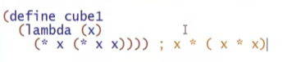

* Lambda
  + This is anonymous function keyword
    - fn x => x \* (x \* x)

We can also write it like this because the “\*” (multiply function) here in racket can take ANY number of arguments

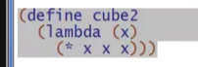

Syntactic sugar for lambda (the only syntactic sugar in racket)



Conditionals

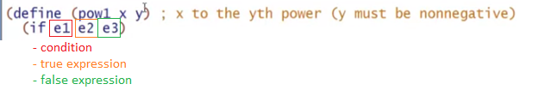

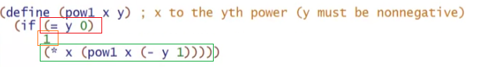

Currying in Racket

* not common because racket has a built-in support for multiple arguments

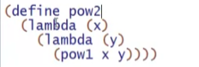

* pow 2 = fn x => fn y => pow1 x y

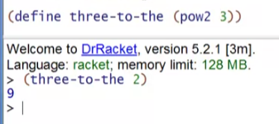

But currying is not too ideal in racket, because parenthesis matter!

